the Eisenhower priority matrix

 |  | When is this task due?
 |  | Urgent | Not Urgent
Does this task contribute to my marks? | Important | DO NOW (QUAD OF NECESSITY) | DO ASAP (QUAD OF QUALITY)
 |  | (I) Important & Urgent | (II) Important & Not Urgent
 |  | Tasks that count towards your marks or increase workload if not completed & are due by tomorrow | Tasks that count towards your marks or increase workload if not completed & are due in the next fortnight
 |  | Close deadlines (due today or tomorrow)  High level of importance (contributes to your marks)  Emergencies & crises  Last minute changes  Last minute preparations | Getting started early  Long-term projects/tasks  Preparation & planning  Prevention of major problems  Studying in advance  Thinking & research
 | Not Important | DELEGATE | DELETE | DO THE MINIMUM (QUAD OF DECEPTION) | IGNORE (QUAD OF WASTE)
 |  | (III) Not Important & Urgent | (IV) Not Important & Not Urgent
 |  | Tasks that don’t contribute to your marks and won’t increase your study load if ignored, but need to be completed by tomorrow | Tasks that don’t contribute to your marks and won’t increase your study load if ignored, and can be done at any stage
 |  | Fun/social events  Interruptions & distractions  Meeting other people’s priorities & expectations  Other people’s emergencies  Unscheduled tasks/visitors | Computer games & escape activities  Over analysis & perfectionism  Procrastination activities  Social media & web browsing  Time wasters  Emails, texts, calls & TV

Eisenhower priority matrix

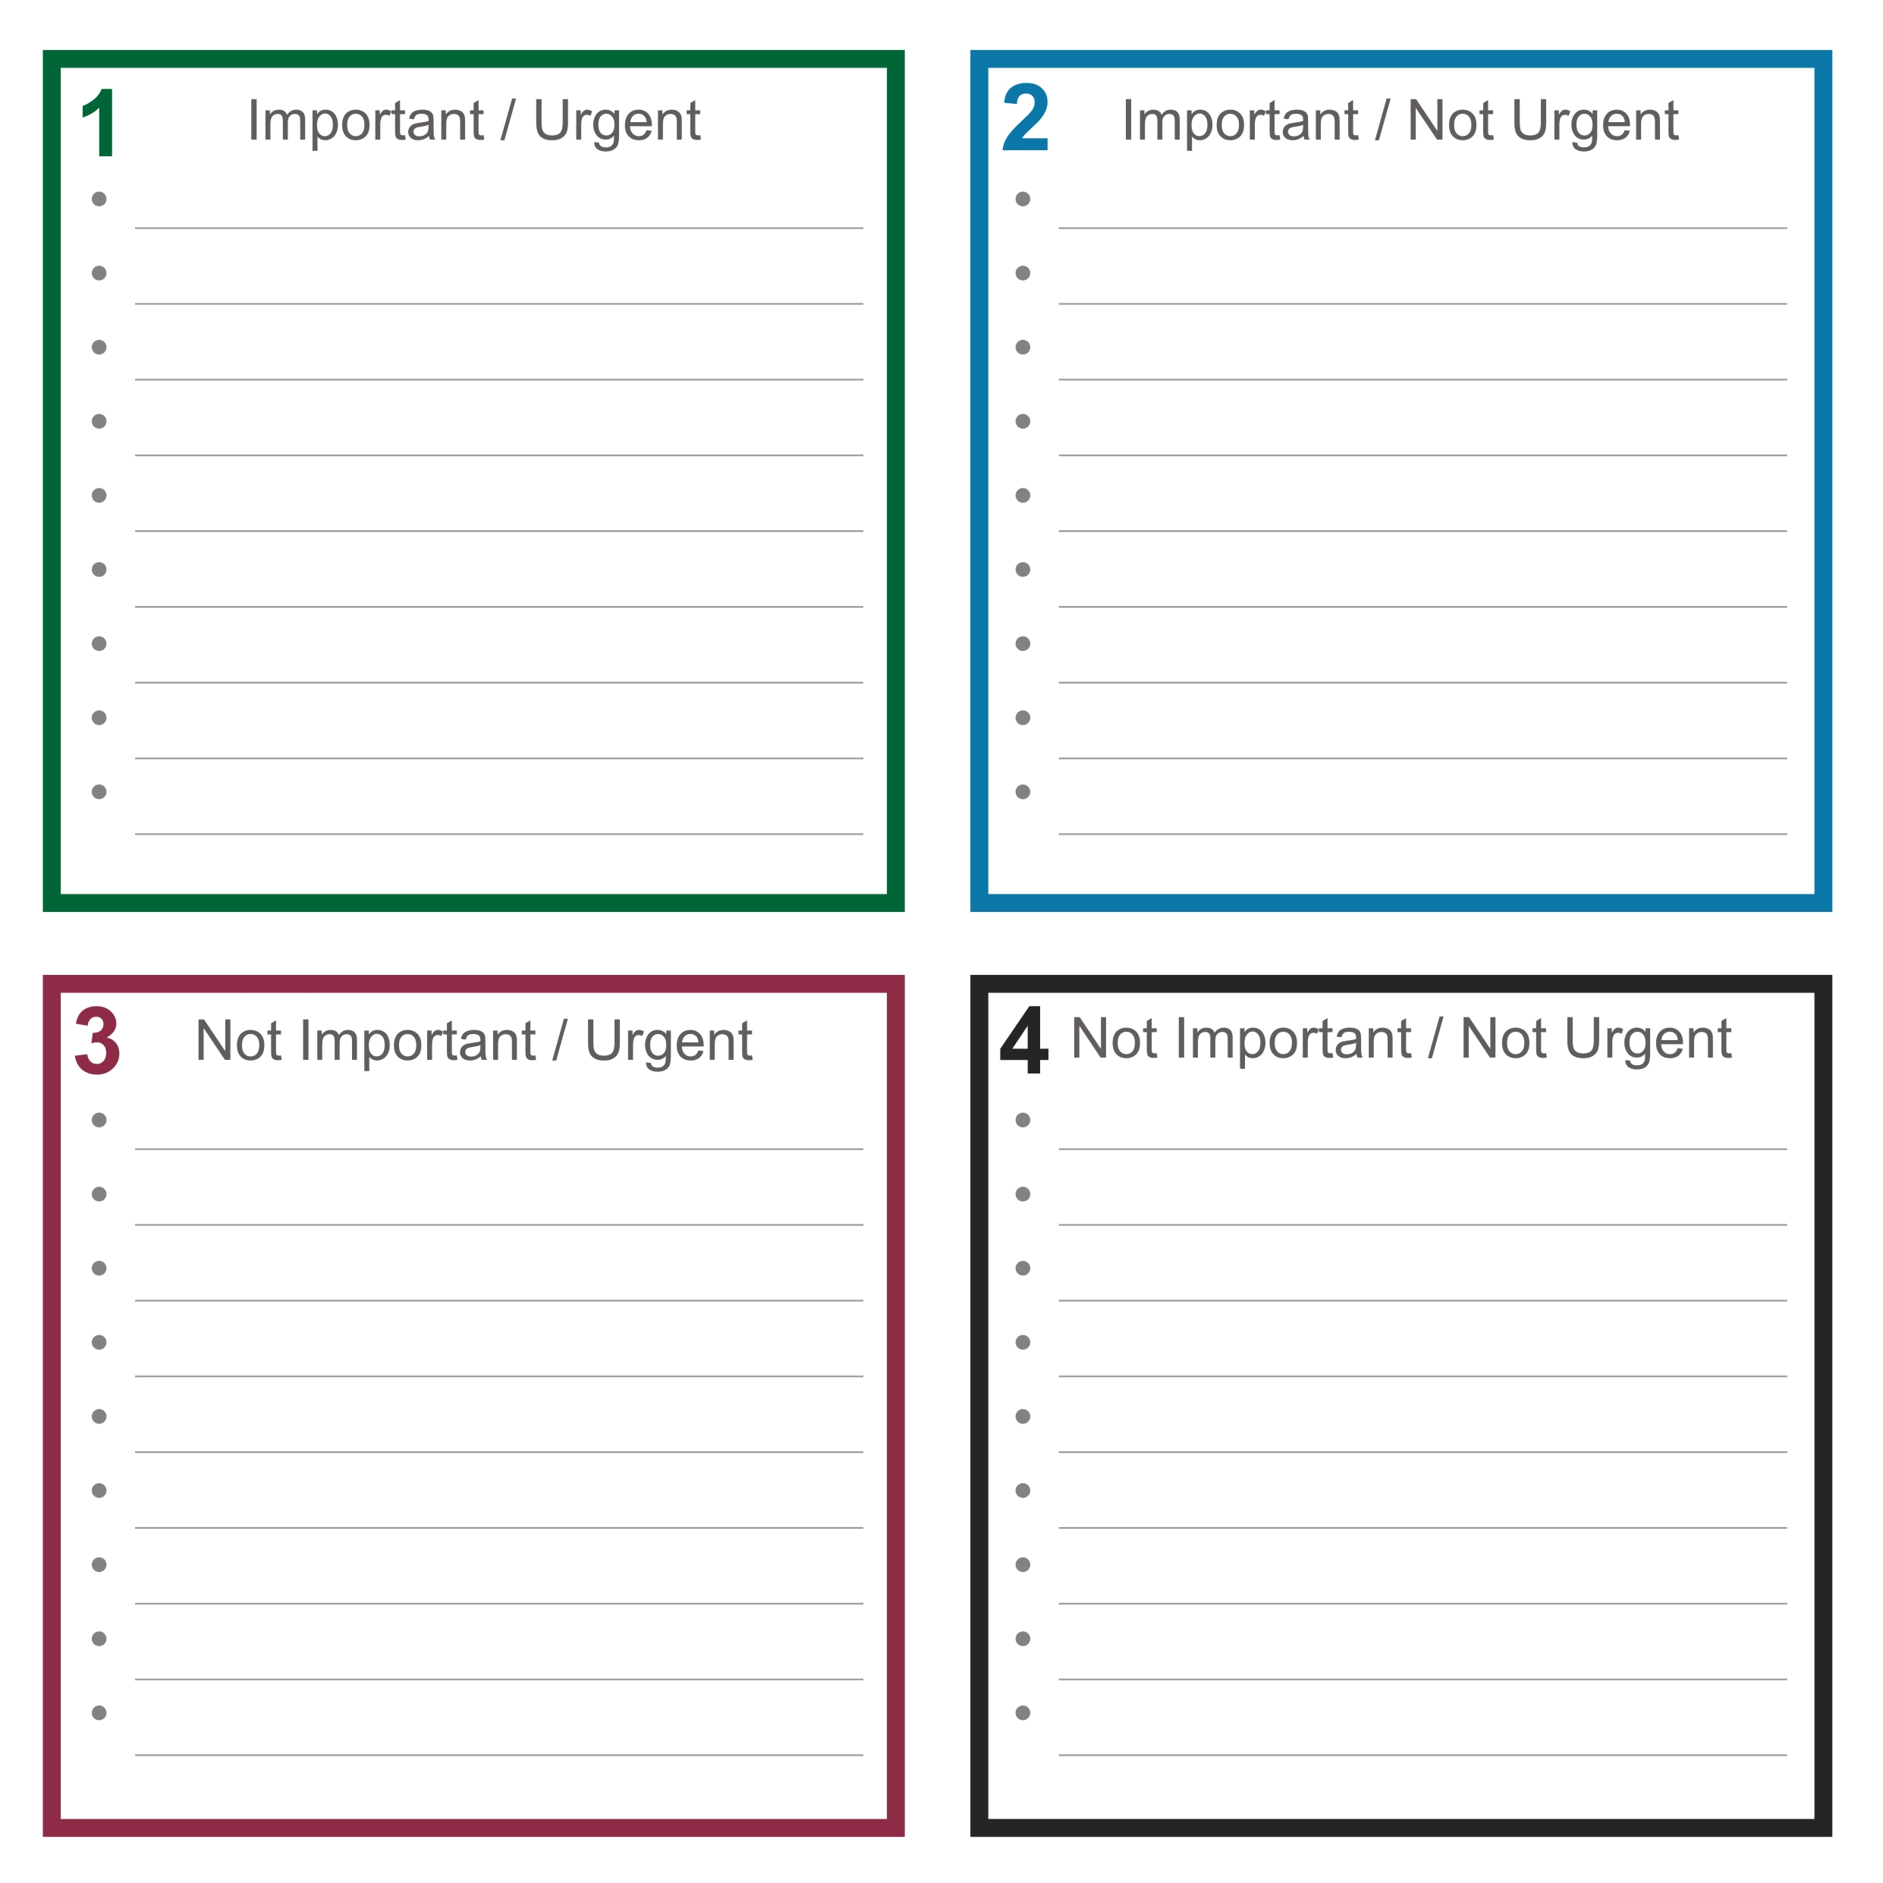

HSC student activities & quadrant allocations

Task | Due | Important  Urgent | Important  Not Urgent | Not Important  Urgent | Not Important  Not Urgent
General Homework (Difficult Topic) | Next Day | 3
General Homework (Easy Topic) | Next Day |  | 3
Essay/Assignment (Counts for Marks) | Next Day | 3
Essay/Assignment (Counts for Marks) | Next Week |  | 3
Internal assessments | Next Day | 3
Internal assessments | Next Week |  | 3
Writing Notes/Summaries | Next Day |  |  | 3
Writing Notes/Summaries | Next Week |  |  |  | 3
Memorising Materials | Next Day | 3
Memorising Materials | Next Week |  | 3
Revising Materials for Test/Exam | Next Day | 3
Revising Materials for Test/Exam | Next Week |  | 3
Working Through Exam Papers | Next Day | 3
Working Through Exam Papers | Next Week |  | 3
Preparing Flashcards |  |  | 3
Getting Ahead |  | 3 | 3
Private Tuition |  | 3 | 3
Practise Essays |  |  | 3
Exam Revision Lectures |  | 3 | 3
Searching for Images |  |  |  |  | 3
Rewriting Notes Neatly |  |  |  |  | 3
Reworking Quality Work to Improve Marks |  |  |  |  | 3
Photocopying/Scanning |  |  |  |  | 3
Study Groups |  |  |  |  | 3
Getting Help from a Teacher |  | 3 | 3
Rereading English Texts |  |  | 3
Reworking Questions from Textbook |  |  |  |  | 3
Feeling Very Ill |  | 3
Finishing an Assessment that’s Due |  | 3
Friend is Very Ill |  |  |  | 3
Guests Drop By |  |  |  | 3
Phone Texts |  |  |  |  | 3
Facebook |  |  |  |  | 3
Daydreaming |  |  |  |  | 3
Going for a Walk |  |  | 3
Family Time |  |  | 3

